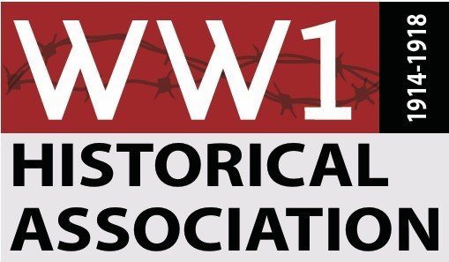

RESTRICTED GIFT AGREEMENT
Between
World War I Historical Association and ____________________________
This Gift Agreement (“Agreement”) is made this ________ day of ____________ between ___________________ and their assignee (hereinafter referred to as “the Donor”), and the World War I Historical Association “a nonprofit 501(c)(3) organization” located in the State of Michigan. The Donor and the World War I Historical Association agree as follows:
- Donor Commitment. The Donor hereby pledges to the World War I Historical Association the sum of $______________, which as provided for herein is designated for the benefit of ____________________________ Endowment.

- Donor Purpose. It is understood and agreed that the gift will be used for the following purpose or purposes. To establish an endowment from which the annual interest earnings will be used to ___________________________________________________________.

- Payment. It is further understood and agreed that the gift will be paid in full on or before _____________. Pledge payments will be made as follows:

Date Amount

____________________________ __________________________________

____________________________ __________________________________

____________________________ __________________________________

____________________________ __________________________________

____________________________ __________________________________

It is also understood and agreed that the gift funds received may be invested by a third party that shall best determine investment options for this endowment fund. The spending policy for the endowment will be the policy set forth and approved by the World War I Historical Association Board of Directors which will likely include the use of annual interest earnings only and not invade the principal of the fund to protect and perpetuate growth.

- Endowment. The gift specified above shall be used for the purpose of creating an endowment fund to be known as the ___________________ (“Fund”). The assets of the Fund may be merged or pooled for investment and investment management purposes with the general endowment or other assets of the World War I Historical Association and managed and invested in accordance with World War I Historical Association policy and procedure but shall be entered on the books and records of the World War I Historical Association as the _____________________ Fund. Distributions in support of the above gift purpose and reasonable fees associated with securing, raising, investing, and administering such funds shall be charged to the said Fund administered in accordance with the policies and procedures of the World War I Historical Association then in effect.

- Intent. It is the agreement of the parties and the intention of the Donor that this gift and any unpaid promised installment under this Agreement shall constitute the Donor’s binding obligation and shall be enforceable at law and equity, including, without limitation, against the Donor and the Donor’s estate, heirs, and personal representatives, and their successors and assignees. The Donor acknowledges that the World War I Historical Association has substantially relied and shall continue to rely on the Donor’s gift being fully satisfied as set forth herein.

- Recognition by the World War I Historical Association. To honor the Donor, and to express the appreciation of the World War I Historical Association, publicity in the form of announcements, both internal and external, will be made in the annual report with the permission of the Donor.

- Reporting and Stewardship. Reports on performance of the Fund and use of the proceeds shall be provided annually to the Donor for endowment gifts.

- Additional Gifts. The Donor reserves the right to increase the Fund through additional gifts and hereby consents to additional contributions to the Fund by any individual, corporation, foundation, trust, estate, or other legal entity through individual gift, bequest or other gift vehicle, and all gifts designated shall be subject to the provisions of this Agreement.

- Future Changed Circumstances. If, in the opinion of the Board of Directors of the World War I Historical Association, all or part of this gift cannot at some time in the future be usefully or practically applied to the above purposes or if the purpose cannot be achieved because of a future change in law or unforeseeable circumstances, it may be used for any related purpose which in the opinion of the Board of Directors will most nearly accomplish the Donor’s wishes.

- Amendment. By mutual consent of the World War I Historical Association and the Donor, the Donor’s legally or duly appointed agent or attorney-in-fact, or the personal representatives of the Donor’s estate, any provision of this Agreement may be amended, modified, or deleted. Any such changes, deletions or additions shall be recorded in written signed addenda, which shall form part of this Agreement.

- Morality Clause. If at any time the Donor or his or her name may compromise the public trust or the reputation of the World War I Historical Association, including acts of moral turpitude, the World War I Historical Association with the approval of the Board of Directors has the right to remove the name of the Donor or return the gift.

- Entire Agreement. This Agreement contains the entire understanding of the parties with respect to the subject matter of the Agreement and is subject to the laws of the State of Michigan. This Agreement also supersedes all other agreements and understandings, both oral and written, between the parties relating to the subject matter of the Agreement.

In witness whereof, the parties to the Agreement have affixed their signatures:

___________________________________ ________________________________
Donor’s Name President’s Name
World War I Historical Association

___________________________________ ________________________________
Date Date

___________________________________ ________________________________
Witness Witness

___________________________________ ________________________________
Date Date

